COMPUTER NETWORK LABORATORY
[As per Choice Based Credit System (CBCS) scheme]
(Effective from the academic year 2016 -2017)
SEMESTER – V
Subject Code 18CSL57 IA Marks 20
Number of Lecture Hours/Week 01I + 02P Exam Marks 80
Total Number of Lecture Hours 40 Exam Hours 03

CREDITS – 02
Course objectives: This course will enable students to
· Demonstrate operation of network and its management commands
· Simulate and demonstrate the performance of GSM and CDMA
· Implement data link layer and transport layer protocols.
Description (If any):
For the experiments below modify the topology and parameters set for the experiment and take multiple rounds of reading and analyze the results available in log files. Plot necessary graphs and conclude using any suitable tool.

Lab Experiments:

PART A
1. Implement three nodes point – to – point network with duplex links between them. Set the queue size, vary the bandwidth and find the number of packets dropped.
2. Implement transmission of ping messages/trace route over a network topology consisting of 6 nodes and find the number of packets dropped due to congestion.
3. Implement an Ethernet LAN using n nodes and set multiple traffic nodes and plot congestion window for different source / destination.
4. Implement simple ESS and with transmitting nodes in wire-less LAN by simulation and determine the performance with respect to transmission of packets.
5. Implement and study the performance of GSM on NS2/NS3 (Using MAC layer) or equivalent environment.
6. Implement and study the performance of CDMA on NS2/NS3 (Using stack called Call net) or equivalent environment.

PART B
Implement the following in Java:
7. Write a program for error detecting code using CRC-CCITT (16- bits).
8. Write a program to find the shortest path between vertices using bellman-ford algorithm.
9. Using TCP/IP sockets, write a client – server program to make the client send the file name and to make the server send back the contents of the requested file if present. Implement the above program using as message queues or FIFOs as IPC channels.
10. Write a program on datagram socket for client/server to display the messages on client side, typed at the server side.
11. Write a program for simple RSA algorithm to encrypt and decrypt the data.
12. Write a program for congestion control using leaky bucket algorithm.

Study Experiment / Project: NIL

Course outcomes: The students should be able to:
· Analyze and Compare various networking protocols.
· Demonstrate the working of different concepts of networking.
· Implement, analyze and evaluate networking protocols in NS2 / NS3

Conduction of Practical Examination:
1. All laboratory experiments are to be included for practical examination.
2. Students are allowed to pick one experiment from part A and part B with lot.
3. Strictly follow the instructions as printed on the cover page of answer script
4. Marks distribution: Procedure + Conduction + Viva: 80
Part A: 5+30+5 =40
Part B: 5+30+5 =40
5. Change of experiment is allowed only once and marks allotted to the procedure part to be
made zero.

PART A

Introduction to NS-2:

- Widely known as NS2, is simply an event driven simulation tool.
- Useful in studying the dynamic nature of communication networks
- Simulation of wired as well as wireless network functions and protocols (e.g., routing algorithms, TCP, UDP) can be done using NS2.
- In general, NS2 provides users with a way of specifying such network protocols and simulating their corresponding behaviors.

Basic Architecture of NS2
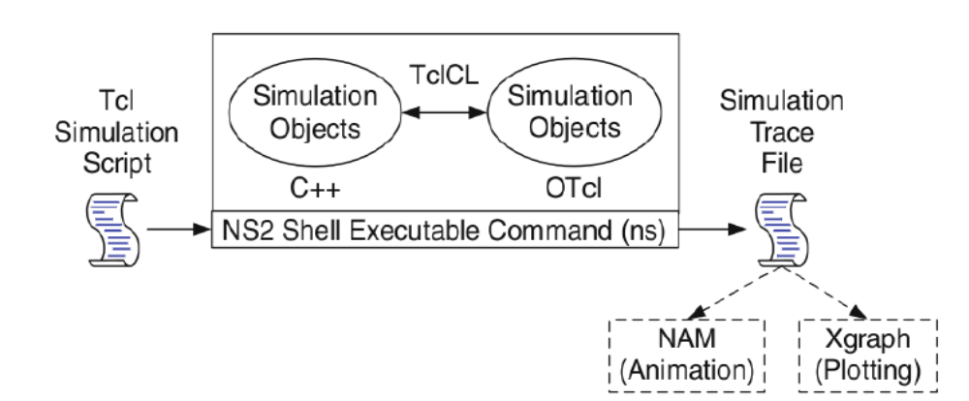

Tcl scripting
• Tcl is a general purpose scripting language. [Interpreter]
• Tcl runs on most of the platforms such as Unix, Windows, and Mac.
• The strength of Tcl is its simplicity.
• It is not necessary to declare a data type for variable prior to the usage.
Basics of TCL

Syntax: command arg1 arg2 arg3

- Hello World:
puts stdout{Hello, World!}
Hello, World!
- Variables: Command Substitution

set a 5 set len [string length foobar]
set b $a set len [expr [string length foobar] + 9]

- Simple Arithmetic: expr 7.2 / 4

- Procedures

proc Diag {a b} {
set c [expr sqrt($a * $a + $b * $b)]
return $c }
puts ―Diagonal of a 3, 4 right triangle is [Diag 3 4]‖

Output: Diagonal of a 3, 4 right triangle is 5.0

-  Loops

while{$i < $n} { for {set i 0} {$i < $n} {incr i} {
. . . . . .
} }
Initialization and Termination of TCL Script in NS-2 :
An ns simulation starts with the command
set ns [new Simulator]

Which is thus the first line in the tcl script? This line declares a new variable as using the set command, you can call this variable as you wish, In general people declares it as ns because it is an instance of the Simulator class, so an object the code[new Simulator] is indeed the installation of the class Simulator using the reserved word new. In order to have output files with data on the simulation (trace files) or files used for visualization (nam files), we need to create the files using ―open command:
#Open the Trace file
set tracefile1 [open out.tr w]
$ns trace-all $tracefile1
#Open the NAM trace file
set namfile [open out.nam w]
$ns namtrace-all $namfile

The above creates a dta trace file called ―out.tr and a nam visualization trace file called ―out.nam.
Within the tcl script, these files are not called explicitly by their names, but instead by pointers that are declared above and called ―tracefile1 and ―namfile respectively. Remark that they begins with a # symbol.The second line open the file ―out.tr‖ to be used for writing, declared with the letter ―w‖.The third line uses a simulator method called trace-all that have as parameter the name of the file where the traces will go.
The last line tells the simulator to record all simulation traces in NAM input format.It also gives the file name that the trace will be written to later by the command $ns flush-trace.In our case,this will be the file pointed at by the pointer ―$namfile‖,i.e the file ―out.tr‖.
The termination of the program is done using a ―finish procedure.
#Define a “finish” procedure
Proc finish { } {
global ns tracefile1 namfile
$ns flush-trace
Close $tracefile1
Close $namfile
Exec nam out.nam &
Exit 0
}
The word proc declares a procedure in this case called finish and without arguments. The word global is used to tell that we are using variables declared outside the procedure. The simulator method ―flush-trace” will dump the traces on the respective files. The tcl command ―close” closes the trace files defined before and exec executes the nam program for visualization. The command exit will ends the application and return the number 0 as status to the system. Zero is the default for a clean exit. Other values can be used to say that is a exit because something fails.
At the end of ns program we should call the procedure ―finish and specify at what time the termination should occur. For example, $ns at 125.0 “finish” will be used to call ―finish‖ at time 125sec.Indeed,the at method of the simulator allows us to schedule events explicitly.
The simulation can then begin using the command: $ns run

Structure of Trace Files:
When tracing into an output ASCII file, the trace is organized in 12 fields as follows in fig shown below, The meaning of the fields are:
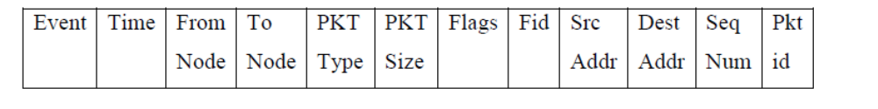

1. The first field is the event type. It is given by one of four possible symbols r, +, -, d which correspond respectively to receive (at the output of the link), enqueued, dequeued and dropped.
2. The second field gives the time at which the event occurs.
3. Gives the input node of the link at which the event occurs.
4. Gives the output node of the link at which the event occurs.
5. Gives the packet type (eg CBR or TCP)
6. Gives the packet size
7. Some flags
8. This is the flow id (fid) of IPv6 that a user can set for each flow at the input OTcl script one can further use this field for analysis purposes; it is also used when specifying stream color for the NAM display.
9. This is the source address given in the form of ―node.port‖.
10. This is the destination address, given in the same form.
11. This is the network layer protocol’s packet sequence number. Even though UDP implementations in a real network do not use sequence number, ns keeps track of UDP packet sequence number for analysis purposes
12. The last field shows the Unique id of the packet.

Awk- An Advanced
awk is a programmable, pattern-matching, and processing tool available in UNIX. It works equally well with text and numbers. awk is not just a command, but a programming language too. In other words, awk utility is a pattern scanning and processing language. It searches one or more files to see if they contain lines that match specified patterns and then perform associated actions, such as writing the line to the standard output or incrementing a counter each time it finds a match.
Syntax:
awk option ‘selection criteria {action}’ file(s)

1. Implement three nodes point – to – point network with duplex links between them. Set the queue size, vary the bandwidth and find the number of packets dropped.

File: lab1.tcl
#Create a new Simulation Instance
set ns [new Simulator]

#Turn on the Trace and the animation files
set f [open out.tr w]
set nf [open out.nam w]

$ns trace-all $f
$ns namtrace-all $nf

#Define the finish procedure to perform at the end of the simulation

proc finish {} {
global f nf ns
$ns flush-trace
close $f
close $nf
exec nam out.nam &
exec awk -f 1.awk out.tr &
exit 0
}

#Create the nodes
set n0 [$ns node]
set n1 [$ns node]
set n2 [$ns node]

#Label the nodes
$n0 label "TCP Source"
$n1 label "UDP Source"
$n2 label "Sink"

#Set the color
$ns color 1 red
$ns color 2 yellow

#Create the Topology
$ns duplex-link $n0 $n1 2Mb 10ms DropTail
$ns duplex-link $n1 $n2 1.75Mb 20ms DropTail

#Attach a Queue of size N Packets between the nodes n1 n2
$ns queue-limit $n1 $n2 10

#Make the Link Orientation
$ns duplex-link-op $n0 $n1 orient right
$ns duplex-link-op $n1 $n2 orient right

#Create a UDP Agent and attach to the node n1
set udp0 [new Agent/UDP]
$ns attach-agent $n0 $udp0

#Create a CBR Traffic source and attach to the UDP Agent
set cbr0 [new Application/Traffic/CBR]
$cbr0 attach-agent $udp0

#Specify the Packet Size and interval
$cbr0 set packetSize_ 500
$cbr0 set interval_ 0.005

#Create a Null Agent and attach to the node n2
set null0 [new Agent/Null]
$ns attach-agent $n2 $null0

#Connect the CBR Traffic source to the Null agent
$ns connect $udp0 $null0

#Create a TCP agent and attach to the node n0
set tcp0 [new Agent/TCP]
$ns attach-agent $n0 $tcp0

#Create a FTP source and attach to the TCP agent
set ftp0 [new Application/FTP]

#Attach the FTP source to the TCP Agent
$ftp0 attach-agent $tcp0

#Create a TCPSink agent and attach to the node n2
set sink [new Agent/TCPSink]
$ns attach-agent $n2 $sink

#Specify the Max file Size in Bytes
$ftp0 set maxPkts_ 1000

#Connect the TCP Agent with the TCPSink
$ns connect $tcp0 $sink

$udp0 set class_ 1
$tcp0 set class_ 2

#Schedule the Events
$ns at 0.1 "$cbr0 start"
$ns at 1.0 "$ftp0 start"
$ns at 4.0 "$ftp0 stop"
$ns at 4.5 "$cbr0 stop"
$ns at 5.0 "finish"
$ns run

File: lab1.awk
#!/usr/bin/awk -f
BEGIN{
cbrPkt=0;
tcpPkt=0;
}

{
if(($1 == "d")&&($5 == "cbr")) {
cbrPkt = cbrPkt + 1;
}
if(($1 == "d")&&($5 == "tcp")) {
tcpPkt = tcpPkt + 1;
}
}

END {
printf "\nNo. of CBR Packets Dropped %d", cbrPkt;
printf "\nNo. of TCP Packets Dropped %d", tcpPkt;
}
Steps for execution:
1.Open vi editor and type program.
2.Program name should have the extension “ .tcl ” vi lab1.tcl
Save the program by pressing ESC :wq and press enter
3.Open vi editor and type awk program. Program name should have the extension “.awk ” vi lab1.awk
Save the program by pressing ESC:wq and press Enter key.
4.Run the simulation program : ns lab1.tcl Here “ns” indicates network simulator. We get the topology shown in the snapshot.
5. Now press the play button in the simulation window and the simulation will begins.
6.After simulation is completed run awk file to see the output:
awk –f lab1.awk lab1.tr
7. To see the trace file contents open the file as : vi lab1.tr

Output:

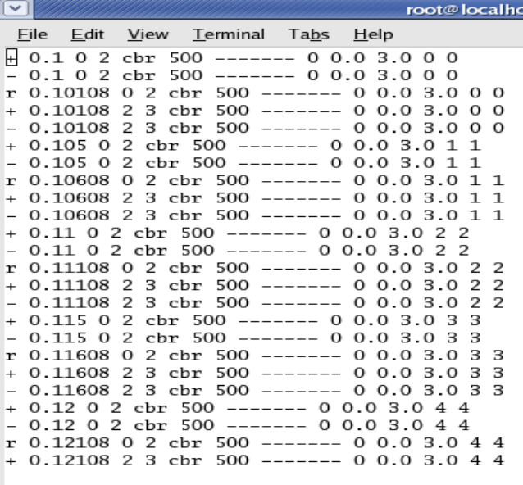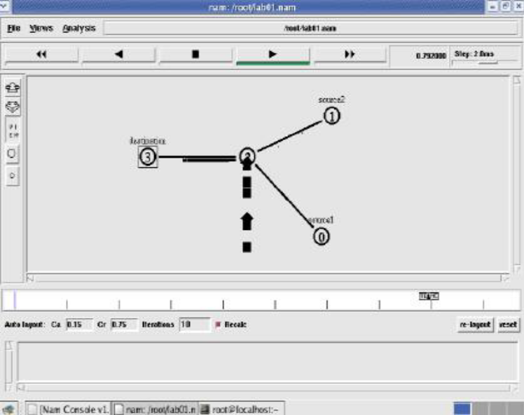
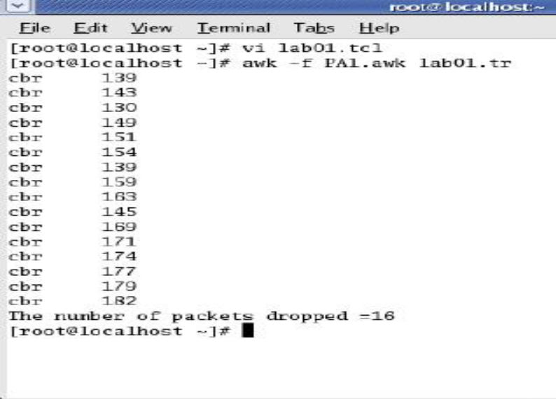

2. Implement transmission of ping messages/trace route over a network topology consisting of 6 nodes and find the number of packets dropped due to congestion.

File : lab2.tcl

set ns [new Simulator]
set f [open out.tr w]
set nf [open out.nam w]

$ns trace-all $f
$ns namtrace-all $nf

proc finish {} {
global ns f nf
$ns flush-trace
close $f
close $nf
exec nam out.nam &
exit 0
}

set n0 [$ns node]
set n1 [$ns node]
set n2 [$ns node]
set n3 [$ns node]
set n4 [$ns node]
set n5 [$ns node]

$n0 label "ping0"
$n1 label "ping1"
$n2 label "R1"
$n3 label "R2"
$n4 label "ping4"
$n5 label "ping5"

$ns color 1 red
$ns color 2 blue
$ns color 3 green
$ns color 4 orange

$ns duplex-link $n0 $n2 1Mb 10ms DropTail
$ns duplex-link $n1 $n2 1Mb 10ms DropTail
$ns duplex-link $n2 $n3 0.4Mb 30ms DropTail
$ns duplex-link $n3 $n4 1Mb 10ms DropTail
$ns duplex-link $n3 $n5 1Mb 10ms DropTail

set ping0 [new Agent/Ping]
$ns attach-agent $n0 $ping0

set ping1 [new Agent/Ping]
$ns attach-agent $n1 $ping1

set ping4 [new Agent/Ping]
$ns attach-agent $n4 $ping4

set ping5 [new Agent/Ping]
$ns attach-agent $n5 $ping5

$ns connect $ping0 $ping4
$ns connect $ping1 $ping5

proc sendPingPacket {} {
global ns ping0 ping1
set intervalTime 0.001
set now [$ns now]
$ns at [expr $now + $intervalTime] "$ping0 send"
$ns at [expr $now + $intervalTime] "$ping1 send"
$ns at [expr $now + $intervalTime] "sendPingPacket"
}

Agent/Ping instproc recv {from rtt} {
global seq
$self instvar node_
puts "The node [$node_ id] received an ACK from the node $from with RTT $rtt ms"
}

$ping0 set class_ 1
$ping1 set class_ 2
$ping4 set class_ 4
$ping5 set class_ 5

$ns at 0.01 "sendPingPacket"
$ns at 10.0 "finish"
$ns run

AWK file: lab2.awk

BEGIN{
drop=0;
}
{
if($1= ="d" )
{
drop++;
}
} END{
printf("Total number of %s packets dropped due to congestion =%d\n",$5,drop);

Output:
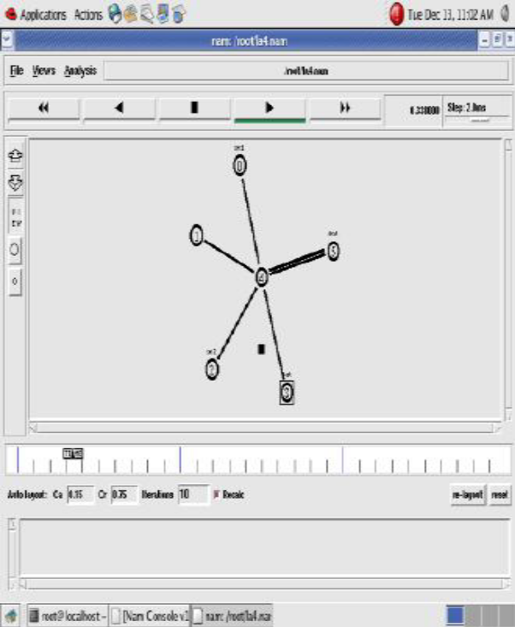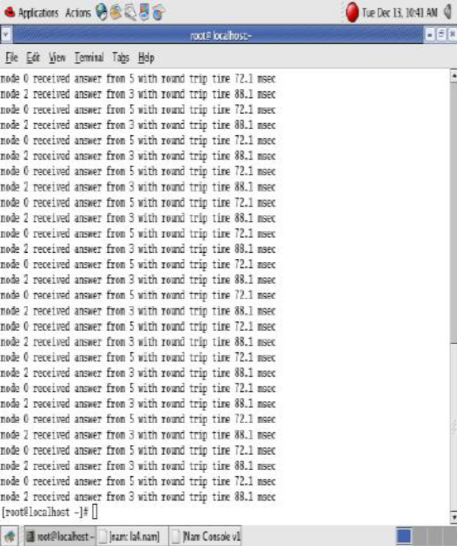
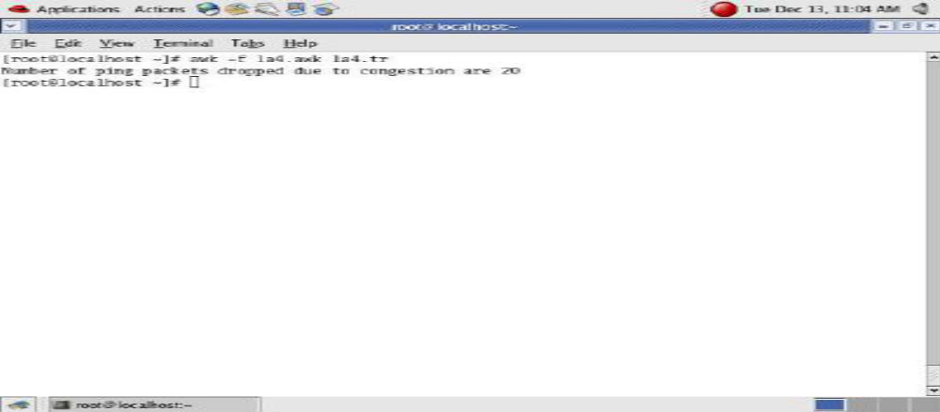
3. Implement an Ethernet LAN using n nodes and set multiple traffic nodes and plot congestion window for different source / destination.

File : lab3.tcl

#set up a new instance of Simulator
set ns [new Simulator]

#Open the trace file and animation file
set f [open 5.tr w]
set nf [open 5.nam w]

$ns trace-all $f
$ns namtrace-all $nf

#Define the finish Procedure
proc finish {} {
global ns f nf outFile1 outFile2
$ns flush-trace
close $f
close $nf
exec nam 5.nam &
exec xgraph Congestion1.xg -geometry 400x400 &
exec xgraph Congestion2.xg -geometry 400x400 &
exit 0
}

$ns color 1 red
$ns color 2 green

#set up the nodes
set n0 [$ns node]
set n1 [$ns node]
set n2 [$ns node]
set n3 [$ns node]
set n4 [$ns node]
set n5 [$ns node]
set n6 [$ns node]
set n7 [$ns node]

#Label the nodes
$n0 label "TCP FTP Source"
$n3 label "Sink Destination"
$n5 label "TCP Telnet Source"
$n7 label "Sink Destination"

#Create the LAN topology
$ns make-lan "$n0 $n1 $n2 $n3 $n4 $n5 $n6 $n7" 10Mb 30ms LL Queue/DropTail Mac/802_3

#Set up the TCP Agents
set tcp1 [new Agent/TCP]
$ns attach-agent $n0 $tcp1
set ftp1 [new Application/FTP]
$ftp1 attach-agent $tcp1
set sink1 [new Agent/TCPSink]
$ns attach-agent $n3 $sink1
$ns connect $tcp1 $sink1
$tcp1 set class_ 1

#Set up the telnet
set tcp2 [new Agent/TCP]
$ns attach-agent $n5 $tcp2
set telnet1 [new Application/FTP]
$telnet1 attach-agent $tcp2
set sink2 [new Agent/TCPSink]
$ns attach-agent $n7 $sink2
$ns connect $tcp2 $sink2
$telnet1 set type_ $sink2
$tcp2 set class_ 2

set outFile1 [open Congestion1.xg w]
set outFile2 [open Congestion2.xg w]

puts $outFile1 "TitleText: Congestion Window Plot for TCP1"
puts $outFile1 "XUnitText: SimulationTime(Secs)"
puts $outFile1 "YUnitText: CongestionWindowSize"
puts $outFile2 "TitleText: Congestion Window Plot for TCP2"
puts $outFile2 "XUnitText: SimulationTime(Secs)"
puts $outFile2 "YUnitText: CongestionWindowSize"

#define findWindowSize
proc findWindowSize {tcpSource outFile} {
global ns
set now [$ns now]
set cWindSize [$tcpSource set cwnd_]
puts $outFile "$now $cWindSize"
$ns at [expr $now + 0.1] "findWindowSize $tcpSource $outFile"
}

#schedule the events
$ns at 0.0 "findWindowSize $tcp1 $outFile1"
$ns at 0.1 "findWindowSize $tcp2 $outFile2"
$ns at 0.3 "$ftp1 start"
$ns at 0.5 "$telnet1 start"
$ns at 50.0 "$ftp1 stop"
$ns at 50.0 "$telnet1 stop"
$ns at 50.0 "finish"
$ns run

Output:
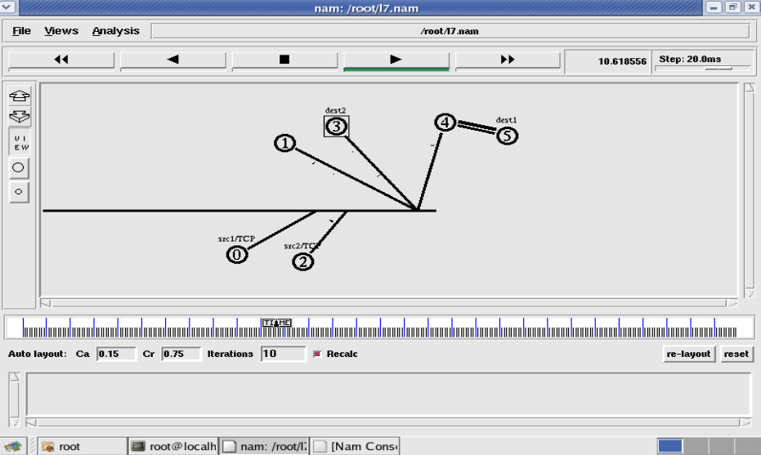

4. Implement simple ESS and with transmitting nodes in wire-less LAN by simulation and determine the performance with respect to transmission of packets.

File : lab4.tcl

if {$argc != 1} {
error "Command: ns <ScriptName.tcl> <Number_of_Nodes>"
exit 0
}

#Define the simulation options
set val(chan) Channel/WirelessChannel
set val(prop) Propagation/TwoRayGround
set val(ant) Antenna/OmniAntenna
set val(ll) LL
set val(ifq) Queue/DropTail/PriQueue
set val(ifqlen) 50
set val(netif) Phy/WirelessPhy
set val(mac) Mac/802_11
set val(rp) AODV
set val(nn) [lindex $argv 0]
set opt(x) 750
set opt(y) 750
set val(stop) 100

set ns [new Simulator]
set trfd [open Wireless.tr w]
set namfd [open Wireless.nam w]

$ns trace-all $trfd
$ns namtrace-all-wireless $namfd $opt(x) $opt(y)

set topo [new Topography]
$topo load_flatgrid $opt(x) $opt(y)
set god_ [create-god $val(nn)]

#Configure the nodes
$ns node-config -adhocRouting $val(rp) \
-llType $val(ll) \
-macType $val(mac) \
-ifqType $val(ifq) \
-channelType $val(chan) \
-propType $val(prop) \
-antType $val(ant) \
-ifqLen $val(ifqlen) \
-phyType $val(netif) \
-topoInstance $topo \
-agentTrace ON \
-routerTrace ON \
-macTrace OFF \
-movementTrace OFF

for {set i 0} {$i < $val(nn)} {incr i} {
set n($i) [$ns node]
}

#Randomly placing the nodes
for {set i 0} {$i < $val(nn)} {incr i} {
set XX [expr rand()*750]
set YY [expr rand()*750]
$n($i) set X_ $XX
$n($i) set Y_ $YY
}

for {set i 0} {$i < $val(nn)} {incr i} {
$ns initial_node_pos $n($i) 30
}

set tcp1 [new Agent/TCP]
$ns attach-agent $n(1) $tcp1

set ftp1 [new Application/FTP]
$ftp1 attach-agent $tcp1

set sink1 [new Agent/TCPSink]
$ns attach-agent $n(3) $sink1

$ns connect $tcp1 $sink1

$ns at 0.0 "destination"
proc destination {} {
global ns val n
set now [$ns now]
set time 5.0
for {set i 0} {$i < $val(nn)} {incr i} {
set XX [expr rand()*750]
set YY [expr rand()*750]
$ns at [expr $now + $time] "$n($i) setdest $XX $YY 20.0"
}
$ns at [expr $now + $time] "destination"
}

#tell nodes when the simulation ends
for {set i 0} {$i < $val(nn)} {incr i} {
$ns at $val(stop) "$n($i) reset"
}

$ns at 5.0 "$ftp1 start"

$ns at $val(stop) "$ns nam-end-wireless $val(stop)"
$ns at $val(stop) "stop"

proc stop {} {
global ns trfd namfd
close $trfd
close $namfd
exec nam Wireless.nam &
exec awk -f 6.awk Wireless.tr &
exit 0
}

$ns run

File : lab4.awk

BEGIN{
PacketRcvd=0;
Throughput=0.0;
}
{
if(($1=="r")&&($3=="_3_")&&($4=="AGT")&&($7=="tcp")&&($8>1000))
{
PacketRcvd++;
}
}
END {
Throughput=((PacketRcvd*1000*8)/(95.0*1000000));
printf "the throughput is:%f\n",Throughput;
}

5. Implement and study the performance of GSM on NS2/NS3 (Using MAC layer) or equivalent environment.
#set Parameters
set stop 100 ;# Stop time.

# Topology
set type gsm ;#type of link:

# AQM parameters
set minth 30
set maxth 0
set adaptive 1 ;# 1 for Adaptive RED, 0 for plain RED

# Traffic generation.
set flows 0 ;# number of long-lived TCP flows
set window 30 ;# window for long-lived traffic

# Plotting statistics.
set opt(wrap) 100 ;# wrap plots?
set opt(srcTrace) is ;# where to plot traffic
set opt(dstTrace) bs2 ;# where to plot traffic

#default downlink bandwidth in bps
set bwDL(gsm) 9600

#default downlink propagation delay in seconds
set propDL(gsm) .500

set ns [new Simulator]

set tf [open Mlab5.tr w]
$ns trace-all $tf

set nodes(is) [$ns node]
set nodes(ms) [$ns node]
set nodes(bs1) [$ns node]
set nodes(bs2) [$ns node]
set nodes(lp) [$ns node]

proc cell_topo {} {
global ns nodes
$ns duplex-link $nodes(lp) $nodes(bs1) 3Mbps 10ms DropTail
$ns duplex-link $nodes(bs1) $nodes(ms) 1 1 RED
$ns duplex-link $nodes(ms) $nodes(bs2) 1 1 RED
$ns duplex-link $nodes(bs2) $nodes(is) 3Mbps 50ms DropTail
puts "GSM Cell Topology"
}

proc set_link_params {t} {

global ns nodes bwDL propDL
$ns bandwidth $nodes(bs1) $nodes(ms) $bwDL($t) duplex
$ns bandwidth $nodes(bs2) $nodes(ms) $bwDL($t) duplex

$ns delay $nodes(bs1) $nodes(ms) $propDL($t) duplex
$ns delay $nodes(bs2) $nodes(ms) $propDL($t) duplex

$ns queue-limit $nodes(bs1) $nodes(ms) 10
$ns queue-limit $nodes(bs2) $nodes(ms) 10
}

# RED and TCP parameter
Queue/RED set adaptive_ $adaptive
Queue/RED set thresh_ $minth
Queue/RED set maxthresh_ $maxth
Agent/TCP set window_ $window

#Create topology
switch $type {
gsm -
umts {cell_topo}
}

set_link_params $type
$ns insert-delayer $nodes(ms) $nodes(bs1) [new Delayer]
$ns insert-delayer $nodes(ms) $nodes(bs2) [new Delayer]

# Set up forward TCP connection
if {$flows == 0} {
set tcp1 [$ns create-connection TCP/Sack1 $nodes(is) TCPSink/Sack1 $nodes(lp) 0]
set ftp1 [[set tcp1] attach-app FTP]
$ns at 0.8 "[set ftp1] start"
}

proc stop {} {
global nodes opt tf
set wrap $opt(wrap)
set sid [$nodes($opt(srcTrace)) id]
set did [$nodes($opt(dstTrace)) id]

set a "Mlab5.tr"

set GETRC "../bin/getrc"
set RAW2XG "../bin/raw2xg"

exec $GETRC -s $sid -d $did -f 0 Mlab5.tr | \
$RAW2XG -s 0.01 -m $wrap -r > plot.xgr

exec $GETRC -s $did -d $sid -f 0 Mlab5.tr | \
$RAW2XG -a -s 0.01 -m $wrap >> plot.xgr

exec xgraph -x time -y packets plot.xgr &
exit 0
}
$ns at $stop "stop"
$ns run

6. Implement and study the performance of CDMA on NS2/NS3 (Using stack called Call net) or equivalent environment.
#set parameters
set stop 100 ;# Stop time.

# Topology
set type umts ;#type of link

# AQM parameters
set minth 30
set maxth 0
set adaptive 1 ;# 1 for Adaptive RED, 0 for plain RED

# Traffic generation.
set flows 0 ;# number of long-lived TCP flows
set window 30 ;# window for long-lived traffic

# Plotting statics.
set opt(wrap) 100 ;# wrap plots?
set opt(srcTrace) is ;# where to plot traffic
set opt(dstTrace) bs2 ;# where to plot traffic

#default downlink bandwidth in bps
set bwDL(umts) 384000

#default downlink propagation delay in seconds
set propDL(umts) .150

set ns [new Simulator]

set tf [open Mlab6.tr w]
$ns trace-all $tf

set nodes(is) [$ns node]
set nodes(ms) [$ns node]
set nodes(bs1) [$ns node]
set nodes(bs2) [$ns node]
set nodes(lp) [$ns node]

proc cell_topo {} {
global ns nodes
$ns duplex-link $nodes(lp) $nodes(bs1) 3Mbps 10ms DropTail
$ns duplex-link $nodes(bs1) $nodes(ms) 1 1 RED
$ns duplex-link $nodes(ms) $nodes(bs2) 1 1 RED
$ns duplex-link $nodes(bs2) $nodes(is) 3Mbps 50ms DropTail
puts " umts Cell Topology"
}

proc set_link_para {t} {
global ns nodes bwDL propDL
$ns bandwidth $nodes(bs1) $nodes(ms) $bwDL($t) duplex
$ns bandwidth $nodes(bs2) $nodes(ms) $bwDL($t) duplex

$ns delay $nodes(bs1) $nodes(ms) $propDL($t) duplex
$ns delay $nodes(bs2) $nodes(ms) $propDL($t) duplex

$ns queue-limit $nodes(bs1) $nodes(ms) 20
$ns queue-limit $nodes(bs2) $nodes(ms) 20
}

# RED and TCP parameters
Queue/RED set adaptive_ $adaptive
Queue/RED set thresh_ $minth
Queue/RED set maxthresh_ $maxth
Agent/TCP set window_ $window

#Create topology
switch $type {
umts {cell_topo}
}

set_link_para $type
$ns insert-delayer $nodes(ms) $nodes(bs1) [new Delayer]
$ns insert-delayer $nodes(ms) $nodes(bs2) [new Delayer]

# Set up forward TCP connection
if {$flows == 0} {
set tcp1 [$ns create-connection TCP/Sack1 $nodes(is) TCPSink/Sack1 $nodes(lp) 0]
set ftp1 [[set tcp1] attach-app FTP]
$ns at 0.8 "[set ftp1] start"
}

proc stop {} {
global nodes opt tf
set wrap $opt(wrap)
set sid [$nodes($opt(srcTrace)) id]
set did [$nodes($opt(dstTrace)) id]

set a "Mlab6.tr"

set GETRC "../bin/getrc"
set RAW2XG "../bin/raw2xg"

exec $GETRC -s $sid -d $did -f 0 Mlab6.tr | \
$RAW2XG -s 0.01 -m $wrap -r > plot6.xgr

exec $GETRC -s $did -d $sid -f 0 Mlab6.tr | \
$RAW2XG -a -s 0.01 -m $wrap >> plot6.xgr

exec xgraph -x time -y packets plot6.xgr &
exit 0
}
$ns at $stop "stop"
$ns run

PART B
Implement the following in Java:
7. Write a program for error detecting code using CRC-CCITT (16- bits)

Program:
import java.io.*;
class crc
{
public static void main(String a[]) throws IOException
{

InputStreamReader isr = new InputStreamReader(System.in);
BufferedReader br = new BufferedReader(isr);
int[] message;
int[] gen;
int[] app_message;
int[] rem;
int[] trans_message;
int message_bits,gen_bits, total_bits;

System.out.println("\n Enter number of bits in message : ");
message_bits=Integer.parseInt(br.readLine());
message=new int[message_bits];
System.out.println("\n Enter message bits : ");
for(int i=0; i<message_bits; i++)
message[i]=Integer.parseInt(br.readLine());
System.out.println("\n Enter number of bits in gen : ");
gen_bits=Integer.parseInt(br.readLine());

gen=new int[gen_bits];
System.out.println("\n Enter gen bits : ");
for(int i=0; i<gen_bits; i++)
{
gen[i]=Integer.parseInt(br.readLine());
}
total_bits=message_bits+gen_bits-1;
app_message=new int[total_bits];
rem=new int[total_bits];
trans_message=new int[total_bits];

for(int i=0;i<message.length;i++)
{
app_message[i]=message[i];
}

System.out.print("\n Message bits are : ");
for(int i=0; i< message_bits; i++)
{
System.out.print(message[i]);
}

System.out.print("\n Generators bits are : ");
for(int i=0; i< gen_bits; i++)
{
System.out.print(gen[i]);
}

System.out.print("\n Appended message is : ");
for(int i=0; i< app_message.length; i++)
{
System.out.print(app_message[i]);
}

for(int j=0; j<app_message.length; j++)
{
rem[j] = app_message[j];
}

rem=computecrc(app_message, gen, rem);

for(int i=0;i<app_message.length;i++)
{
trans_message[i]=(app_message[i]^rem[i]);
}

System.out.println("\n Transmitted message from the transmitter is : ");
for(int i=0;i<trans_message.length;i++)
{
System.out.print(trans_message[i]);
}

System.out.println("\n Enter received message of "+total_bits+" bits at receiver end : ");
for(int i=0; i<trans_message.length; i++)
{
trans_message[i]=Integer.parseInt(br.readLine());
}
System.out.println("\n Received message is :");
for(int i=0; i< trans_message.length; i++)
{
System.out.print(trans_message[i]);
}

for(int j=0; j<trans_message.length; j++)
{
rem[j] = trans_message[j];
}
rem=computecrc(trans_message, gen, rem);
for(int i=0; i< rem.length; i++)
{
if(rem[i]!=0)
{
System.out.println("\n There is Error in the received message!!!");
break;
}
if(i==rem.length-1)
{
System.out.println("\n There is No Error in the received message!!!");
}
}
}
static int[] computecrc(int app_message[],int gen[], int rem[])
{
int current=0;
while(true)
{
for(int i=0;i<gen.length;i++)
{
rem[current+i]=(rem[current+i]^gen[i]);
}
while(rem[current]==0 && current!=rem.length-1)
{
current++;
}
if((rem.length-current)<gen.length)
{
break;
}
}
return rem;
}
}

OUTPUT:Enter the number of bits in message:
5
Enter message bits:
1
0
1
1
0
Enter number of bits in gen:
3
Enter gen bits:
1
0
1
Message bits are:10110
Generator bits are:101
Appended message is:1011000
Transmitted message from the trasmitter is:
1011010
Enter received message of 7 bits at receiver end:
1
0
1
1
0
1
1
Received message is :
1011011
There is error in the received message!!!

8. Write a program to find the shortest path between vertices using bellman-ford algorithm.

PROGRAM:

import java.util.Scanner;
public class BellmanFord
{
private int distances[];
private int numberofvertices;
public static final int MAX_VALUE = 999;
public BellmanFord(int numberofvertices)
{
this.numberofvertices = numberofvertices;
distances = new int[numberofvertices + 1];
}
public void BellmanFordEvaluation(int source, int destination,
int adjacencymatrix[][])
{
for (int node = 1; node <= numberofvertices; node++)
{
distances[node] = MAX_VALUE;
}
distances[source] = 0;
for (int node = 1; node <= numberofvertices - 1; node++)
{
for (int sourcenode = 1; sourcenode <= numberofvertices; sourcenode++)
{
for (int destinationnode = 1; destinationnode <= numberofvertices; destinationnode++)
{
if (adjacencymatrix[sourcenode][destinationnode] != MAX_VALUE)
{
if (distances[destinationnode] > distances[sourcenode]
+ adjacencymatrix[sourcenode][destinationnode])
distances[destinationnode] = distances[sourcenode]
+ adjacencymatrix[sourcenode][destinationnode];
}
}
}
}
for (int sourcenode = 1; sourcenode <= numberofvertices; sourcenode++)
{
for (int destinationnode = 1; destinationnode <= numberofvertices; destinationnode++)
{
if (adjacencymatrix[sourcenode][destinationnode] != MAX_VALUE)
{
if (distances[destinationnode] > distances[sourcenode]
+ adjacencymatrix[sourcenode][destinationnode])
System.out.println("The Graph contains negative egde cycle");
} }
}
for (int vertex = 1; vertex <= numberofvertices; vertex++)
{
if (vertex == destination)
System.out.println("distance of source " + source + " to “ + vertex + " is " + distances[vertex]);
}
}
public static void main(String... arg)
{
int numberofvertices = 0;
int source, destination;
Scanner scanner = new Scanner(System.in);
System.out.println("Enter the number of vertices");
numberofvertices = scanner.nextInt();
int adjacencymatrix[][] = new int[numberofvertices + 1][numberofvertices + 1];
System.out.println("Enter the adjacency matrix");
for (int sourcenode = 1; sourcenode <= numberofvertices; sourcenode++)
{
for (int destinationnode = 1; destinationnode <= numberofvertices; destinationnode++)
{
adjacencymatrix[sourcenode][destinationnode] = scanner
.nextInt();
if (sourcenode == destinationnode)
{
adjacencymatrix[sourcenode][destinationnode] = 0;
continue;
}
if (adjacencymatrix[sourcenode][destinationnode] == 0)
{
adjacencymatrix[sourcenode][destinationnode] = MAX_VALUE;
}
}
}
System.out.println("Enter the source vertex");
source = scanner.nextInt();
System.out.println("Enter the destination vertex: ");
destination = scanner.nextInt();
BellmanFord bellmanford = new BellmanFord(numberofvertices);
bellmanford.BellmanFordEvaluation(source, destination, adjacencymatrix);
scanner.close();
}
}
OUTPUT: Enter the number of vertices 5
Enter the adjacency matrix
0 999 6 3 999
3 0 999 999 999
999 999 0 2 999
999 1 1 0 999
999 4 999 2 0
Enter the source vertex
5
Enter the destination vertex
1
Distance of source 5 to 1 is 6
9. Using TCP/IP sockets, write a client – server program to make the client send the file name and to make the server send back the contents of the requested file if present. Implement the above program using as message queues or FIFOs as IPC channels.

Client side:
import java.io.BufferedReader;
import java.io.BufferedWriter;
import java.io.DataInputStream;
import java.io.InputStreamReader;
import java.io.DataOutputStream;
//import java.io.OutputStreamWriter;
//import java.net.InetAddress;
import java.net.Socket;
import java.io.File;
import java.io.FileOutputStream;
import java.util.Scanner;
class client
{
public static void main(String args[])throws Exception
{
String address="";
Scanner sc= new Scanner(System.in);
System.out.println("eneter server address");
address=sc.nextLine();
Socket s=new Socket(address,5000);
DataInputStream din=new DataInputStream(s.getInputStream());
DataOutputStream dout=new DataOutputStream(s.getOutputStream());
BufferedReader br=new BufferedReader(new InputStreamReader(System.in));
System.out.println("snd get to start");
String str="",filename="";
try
{
while(!str.equals("start"))
str=br.readLine();
dout.writeUTF(str);
dout.flush();
filename=din.readUTF();
System.out.println("receiveing file:"+filename);
filename="client"+filename;
System.out.println("saving as file"+filename);
long sz=Long.parseLong(din.readUTF());
System.out.println("filesize:"+(sz/(1024))+"KB");
byte b[]=new byte[1024];
System.out.println("receiving file");
FileOutputStream fos=new FileOutputStream(new File(filename),true);
long bytesRead;
do
{
bytesRead=din.read(b,0,b.length);
fos.write(b,0,b.length);
}
while(!(bytesRead<1024));
System.out.println("completed");
fos.close();
dout.close();
s.close();
}
catch(Exception e)
{
//do nothing;
}
}
}

Server side:
import java.io.InputStreamReader;
import java.io.DataInputStream;
import java.io.DataOutputStream;
import java.net.Socket;
import java.io.File;
import java.io.FileInputStream;
import java.net.ServerSocket;
import java.util.Scanner;
class Server
{
public static void main(String args[])throws Exception
{
String filename;
System.out.println("eneter filename");
Scanner sc= new Scanner(System.in);
filename=sc.nextLine();
sc.close();
while(true)
{
ServerSocket ss =new ServerSocket(5000);
System.out.println("wait fr req");
Socket s=ss.accept();
System.out.println("connected with" +s.getInetAddress().toString());
DataInputStream din=new DataInputStream(s.getInputStream());
DataOutputStream dout=new DataOutputStream(s.getOutputStream());
try
{
String str="";
str=din.readUTF();
System.out.println("send get tok ");
if(!str.equals("stop"))
{
System.out.println("sendinf file:"+filename);
dout.writeUTF(filename);
dout.flush();
File f=new File(filename);
FileInputStream fin=new FileInputStream(f);
long sz=(int)f.length();
byte b[]=new byte[1024];
int read;
dout.writeUTF(Long.toString(sz));
dout.flush();
System.out.println("size:"+sz);
System.out.println("buffer size:"+ss.getReceiveBufferSize());
while((read=fin.read(b))!=-1)
{
dout.write(b,0,read);
dout.flush();
}
fin.close();
System.out.println("ok");
dout.flush();
}
dout.writeUTF("stop");
System.out.println("sendi complete");
dout.flush();
}
catch(Exception e)
{
e.printStackTrace();
System.out.println("erroe occuerrd");
}
din.close();
s.close();
ss.close();
}
}
}
Output:
1.Open two terminals and create files client.java and Server.java
2.Open a terminal and run the server program and provide the filename to send
3.Open one more terminal,run the client programand provide the IP address of the server(Loopback address)
4.Type “start” at the client side.

Server side:
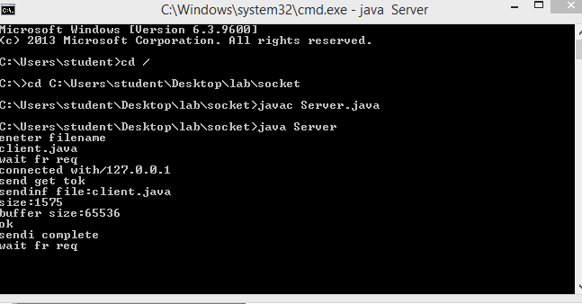
Client side:
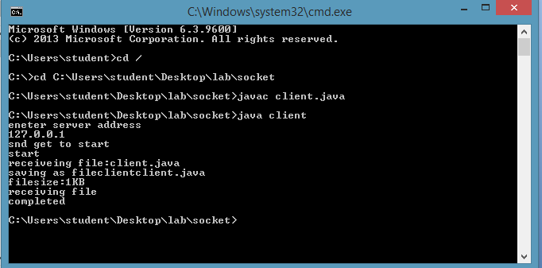

10. Write a program on datagram socket for client/server to display the messages on client side, typed at the server side.

PROGRAM:

import java.net.*;
class datagram {
public static int serverPort = 666;
public static int clientPort = 999;
public static int buffer_size = 1024;
public static DatagramSocket ds;
public static byte buffer[] = new byte[buffer_size];
public static void TheServer() throws Exception {
int pos=0;
while (true) {
int c = System.in.read();
switch(c) {
case -1:
System.out.println("Server Quits.");
return;
case '\r':
break;
case '\n':
ds.send(new DatagramPacket(buffer,pos,InetAddress.getLocalHost(),clientPort));
pos=0;
break;
default:
buffer[pos++] = (byte) c;
}
}
}
public static void TheClient() throws Exception {
while(true) {
DatagramPacket p = new DatagramPacket(buffer, buffer.length);
ds.receive(p);
System.out.println(new String(p.getData(), 0, p.getLength()));
}
}
public static void main(String args[]) throws Exception {
if(args.length == 1) {
ds = new DatagramSocket(serverPort);
TheServer();
} else {
ds = new DatagramSocket(clientPort);
TheClient();
}
}
}
OUTPUT:
Open 2 terminals
In 1st terminal : javac datagram.java
Java datagram
In 2nd terminal :javac datagram.java
Java datagram 1

Server side
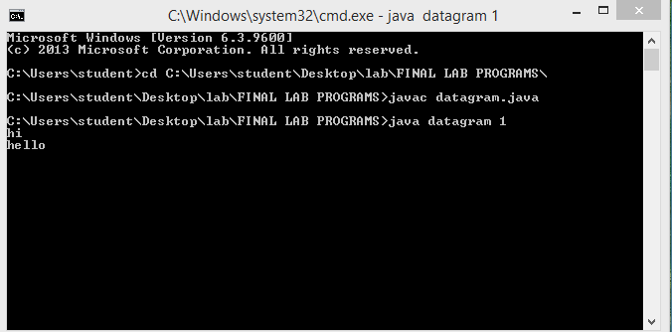

Client side: Displaying the contents
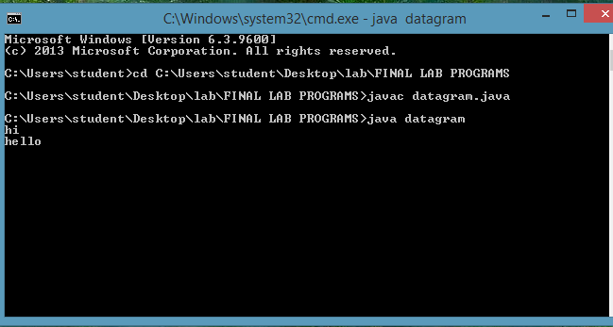

11. Write a program for simple RSA algorithm to encrypt and decrypt the data.

PROGRAM:

import java.io.DataInputStream;
import java.io.IOException;
import java.math.BigInteger;
import java.util.Random;
import java.util.*;

public class encrypt
{
private BigInteger p;
private BigInteger q;
private BigInteger N;
private BigInteger phi;
private BigInteger e;
private BigInteger d;
private int bitlength = 1024;
private Random r;

public encrypt()
{
r = new Random();
p = BigInteger.probablePrime(bitlength, r);
q = BigInteger.probablePrime(bitlength, r);
N = p.multiply(q);
phi = p.subtract(BigInteger.ONE).multiply(q.subtract(BigInteger.ONE));
e = BigInteger.probablePrime(bitlength / 2, r);
while (phi.gcd(e).compareTo(BigInteger.ONE) > 0 && e.compareTo(phi) < 0)
{
e.add(BigInteger.ONE);
}
d = e.modInverse(phi);
}

public encrypt(BigInteger e, BigInteger d, BigInteger N)
{
this.e = e;
this.d = d;
this.N = N;
}

@SuppressWarnings("deprecation")
public static void main(String[] args) throws IOException
{
encrypt encrypt = new encrypt();
DataInputStream in = new DataInputStream(System.in);
String teststring;
System.out.println("Enter the plain text:");
teststring = in.readLine();
System.out.println("Encrypting String: " + teststring);
System.out.println("String in Bytes: "
+ bytesToString(teststring.getBytes()));
// encrypt
byte[] encrypted = encrypt.encrypt(teststring.getBytes());
// decrypt
byte[] decrypted = encrypt.decrypt(encrypted);
System.out.println("Decrypting Bytes: " + bytesToString(decrypted));
System.out.println("Decrypted String: " + new String(decrypted));
}

private static String bytesToString(byte[] encrypted)
{
String test = "";
for (byte b : encrypted)
{
test += Byte.toString(b);
}
return test;
}

// Encrypt message
public byte[] encrypt(byte[] message)
{
return (new BigInteger(message)).modPow(e, N).toByteArray();
}

// Decrypt message
public byte[] decrypt(byte[] message)
{
return (new BigInteger(message)).modPow(d, N).toByteArray();
}
}

OUTPUT:
Enter the plain text:
hi
Encrypting String:hi
String in Bytes: 104105
Decrypting Bytes: 104105
Decrypting String: hi

12. Write a program for congestion control using leaky bucket algorithm.

PROGRAM:
import java.util.*;
public class leaky
{
public static void main(String[] args)
{
Scanner my = new Scanner(System.in);
int no_groups,bucket_size;
System.out.print("\n Enter the bucket size : \t");
bucket_size = my.nextInt();
System.out.print("\n Enter the no of groups : \t");
no_groups = my.nextInt();
int no_packets[] = new int[no_groups];
int in_bw[] = new int[no_groups];
int out_bw,reqd_bw=0,tot_packets=0;
for(int i=0;i<no_groups;i++)
{
System.out.print("\n Enter the no of packets for group " + (i+1) + "\t");
no_packets[i] = my.nextInt();
System.out.print("\n Enter the input bandwidth for the group " + (i+1) + "\t");
in_bw[i] = my.nextInt();
if((tot_packets+no_packets[i])<=bucket_size)
{
tot_packets += no_packets[i];
}
else
{
do
{
System.out.println(" Bucket Overflow ");
System.out.println(" Enter value less than " + (bucket_size-tot_packets));
no_packets[i] = my.nextInt();
}while((tot_packets+no_packets[i])>bucket_size);
tot_packets += no_packets[i];
}
reqd_bw += (no_packets[i]*in_bw[i]);
}
System.out.println("\nThe total required bandwidth is " + reqd_bw);
System.out.println("Enter the output bandwidth ");
out_bw = my.nextInt();
int temp=reqd_bw;
int rem_pkts = tot_packets;
while((out_bw<=temp)&&(rem_pkts>0))
{
System.out.println("Data Sent \n" + (--rem_pkts) + " packets remaining");
System.out.println("Remaining Bandwidth " + (temp -= out_bw));
if((out_bw>temp)&&(rem_pkts>0))
System.out.println(rem_pkts + " packet(s) discarded due to insufficient bandwidth");
}
}
}
OUTPUT:Enter the bucket size:5
Enter the no of groups:1
Enter the no of packets for group1:5
Enter the input bandwidth for the group1:6
The total required bandwidth is 30
Enter the output bandwidth
25
Data sent
4 packets remaining
Remaining Bandwidth: 5
4 packets discarded due to insufficient bandwidth

Viva Questions

- Explain the functions of OSI layers ?
- Differentiate between TCP/IP Layers and OSI Layers
- Why header is required?
- What is the use of adding header and trailer to frames?
- What is encapsulation?
- Why fragmentation requires?
- What is MTU?
- Which layer imposes MTU?
- Differentiate between flow control and congestion control.
- Differentiate between Point-to-Point Connection and End-to-End connections.
- What are protocols running in different layers?
- What is Protocol Stack?
- Differentiate between TCP and UDP.
- Differentiate between Connectionless and connection oriented connection.
- Why frame sorting is required?
- What is meant by subnet?
- What is meant by Gateway?
- What is an IP address?
- What is MAC address?
- Why IP address is required when we have MAC address?
- What is meant by port?
- What are ephemerical port number and well known port numbers?
- What is a socket?
- What are the parameters of socket()?
- Describe bind(), listen(), accept(),connect(), send() and recv().
- What are system calls? Mention few of them.
- What is IPC? Name three techniques.
- Explain mkfifo(), open(), close() with parameters.
- What is meant by file descriptor?
- What is meant by traffic shaping?
- How do you classify congestion control algorithms?
- Differentiate between Leaky bucket and Token bucket.
- How do you implement Leaky bucket?
- How do you generate bursty traffic?
- What is the polynomial used in CRC-CCITT?
- What are the other error detection algorithms?
- What is difference between CRC and Hamming code?
- Why Hamming code is called 7,4 code?
- What is odd parity and even parity?
- What is meant by syndrome?
- What is generator matrix?
- What are Routing algorithms?
- How do you classify routing algorithms? Give examples for each.
- What are drawbacks in distance vector algorithm?
- How routers update distances to each of its neighbor?
- How do you overcome count to infinity problem?
- What is cryptography?
- How do you classify cryptographic algorithms?
- What is public key?
- What is private key?
- What are key, ciphertext and plaintext?
- What is simulation?
- What are advantages of simulation?
- Differentiate between Simulation and Emulation.
- What is meant by router?
- What is meant by bridge?
- What is meant by switch?
- What is meant by hub?
- Differentiate between route, bridge, switch and hub.
- What is ping and telnet?
- What is FTP?
- What is BER?
- What is meant by congestion window?
- What is BSS?
- What is incoming throughput and outgoing throughput?
- What is collision?
- How do you generate multiple traffics across different sender-receiver pairs?
- How do you setup Ethernet LAN?
- What is meant by mobile host?
- Name few other Network simulators
- Differentiate between logical and physical address.
- Which address gets affected if a system moves from one place to another place?
- What is ICMP? What are uses of ICMP? Name few.
- Which layer implements security for data?
- What is flow control and error control?
- What are the protocols used for error control in data link layer.
- What is the difference between?
  - Transferring frames from source to destination.
  - Transferring packets from source to destination.
  - Transferring segments from source to destination.
- Why the message is divided into segments?
- How do we define End to End communication messages using 5 tuples?
- What is Routing? What are the different routing protocols used in N/W layer?
- What is meant by gateway?
- What are the different N/W topologies?
- What is the topology used in your lab?
- What are the three address used to identify a system? Name them? What is their importance?
- What is the need of MAC protocols? Give examples.
- Difference between CSMA/CA and CSMA/CD.
- Why CSMA/CD is not used in WLANS?
- How CSMA/CA is adopted in WLANS?
- What is simulation.Why is it necessary.
- Mentions some simulator tools.

